[NextWork.org](https://community.nextwork.org/c/i-have-a-question?automatic_login=true)

# Deploy an App with CodeDeploy



Prajit Venkatachalam

<https://www.linkedin.com/in/prajit-venkatachalam-435b2a150/>

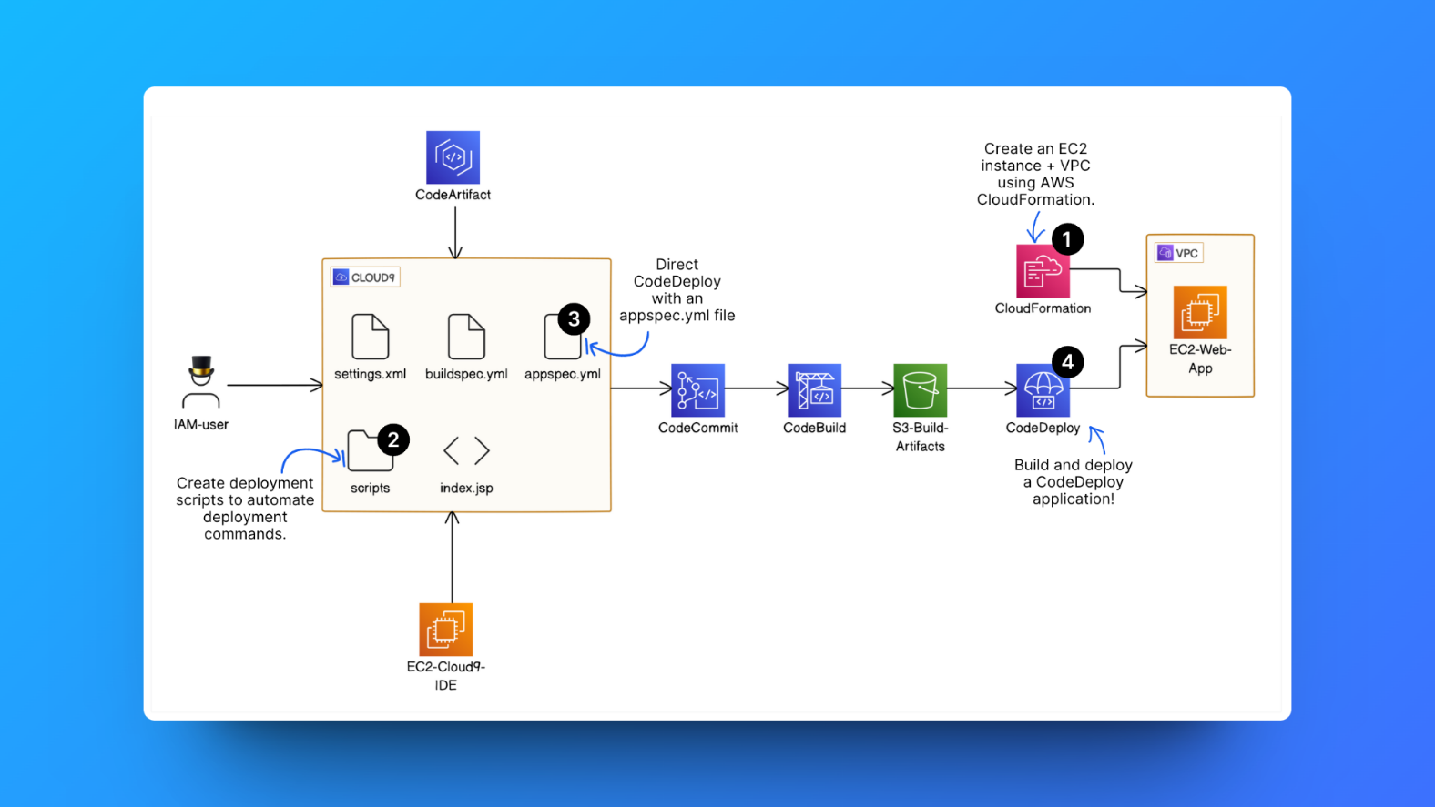

Figure 1: Project plan

## Introducing today's project!

What is AWS CodeDeploy?

AWS CodeDeploy is a deployment service that automates software deployments to various computing environments, such as Amazon EC2 instances, on-premises servers, and Lambda functions. CodeDeploy is useful for automating code deployments, rolling back on failure, and supporting both in-place and blue/green deployment strategies.

How I'm using AWS CodeDeploy in this project

In this project, I used AWS CodeDeploy to automate the deployment of my Java web application on EC2 instances. After setting up the EC2 instance, VPC, and IAM roles, I configured CodeDeploy to manage the deployment process, ensuring smooth updates in both development and production environments.

I created scripts to install dependencies, start, and stop services, and used an **appspec.yml** file to guide the deployment steps. Finally, I integrated CodeDeploy with CodeCommit and S3 to deploy my application WAR file from the build process.

One thing I didn't expect...

One thing I didn't expect in this project was the complexity of the overall configuration. At first, it felt overwhelming, but as I delved deeper, I found it fascinating. The exploration process taught me a great deal of knowledge, and I'm truly grateful for the experience it provided.

This project took me...

This project took me 4 hours to complete including pre setups and report writing.

### **Setups made before starting with AWS CodeBuild**

### **Step 1: Setting up a Web app**

### 1. I set up my web app by launching an EC2 instance in the AWS Console, and I connected to it via SSH using Git Bash

Figure 2: EC2 connected via SSH from Git Bash

### After connecting to my EC2 instance, I set up the development environment by installing Apache Maven and Amazon Corretto 8 (Java version)

### Next, I downloaded Visual Studio Code as an alternative to Cloud9. I connected to the EC2 instance via SSH and set up the Java web application by running the command:

### **mvn archetype:generate \**

### **-DgroupId=com.nextwork.app \**

### **-DartifactId=nextwork-web-project \**

### **-DarchetypeArtifactId=maven-archetype-webapp \**

### **-DinteractiveMode=false**

## 

Figure 3: Maven compiling my Java web app

### After running the above command, a folder named **'nextwork-web-project**' was created in my IDE's (VS Code) file explorer for my project.

Figure 4: Project folder created in vscode file explorer

### **Step 2: Creating a Git repository with AWS CodeCommit**

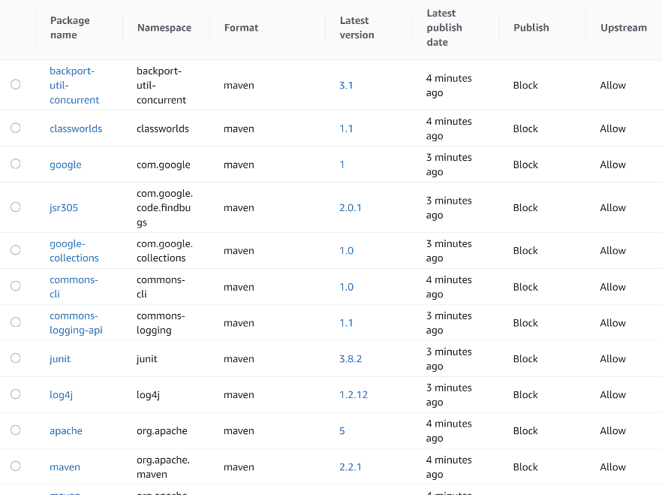

Figure 5: List of packages in CodeCommit dashboard

### I created a Git repository in AWS CodeCommit (main) and had to create a local repository in Visual Studio Code to make changes to the files and push them to the main repository. To do this, I installed Git in VSCode by running the command: **sudo yum install git**

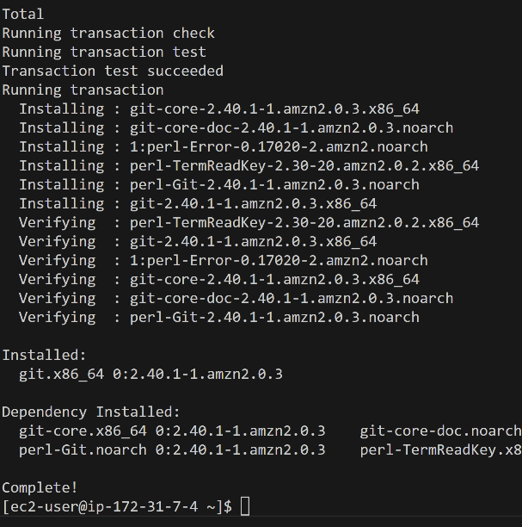

Figure 6: Installed Git in vscode

### Next, I created a Git identity using the following commands

### **git config --global user.name "Prajit"**

### **git config --global user.email "v.prajit98@gmail.com"**

### To create a local repository, I created a project directory in Visual Studio Code by cloning the CodeCommit repository (main). To clone the CodeCommit repository, I used the command:

### **git clone https://git-codecommit.ap-southeast-2.amazonaws.com/v1/repos/nextwork-codedeploy**

### After running the above command, Git prompted for authentication to enter the username and password, as I was using Git over HTTPS. Therefore, I downloaded Git HTTPS credentials from IAM in the AWS Console.

### Next, I navigated to the project directory folder to initialize my local repository. To move to the directory, I used the command:

### **cd ~/nextwork-web-project, and** I initialized the local repository by running the command**: git init -b main**

### Now, I set the remote origin to the main repository by copying the CodeCommit URL from the "Clone URL" option in the repositories section of the AWS Console. I used it in the command:

### **git remote add origin https://git-codecommit.ap-southeast-2.amazonaws.com/v1/repos/nextwork-codedeploy**

### Next, I committed and pushed my code by running the following commands:

### **git add .**

### **git commit -m "Initial commit. Updated index.jsp."**

### **git push -u origin main**

### When I use the command git push -u origin main, Git prompts me for authentication again, requiring me to enter the username and password that I obtained from my HTTPS Git credentials.

Figure 7: CodeCommit dashboard after the first git push

## Step 3: Set up a AWS CodeArtifact

Figure 8:Package flow of CodeArtifact

## Connecting my project with CodeArtifact

## I connected my web app project (via my VS Code IDE) to CodeArtifact, so that CodeArtifact knows to which project it will store the packages or dependencies.

## To connect my web app project to CodeArtifact via Visual Studio Code, I had to use a few commands. The first command is:

## <servers>

## <server>

## <id>devops-3-nextwor-packages</id>

## <username>aws</username>

## <password>${env.CODEARTIFACT_AUTH_TOKEN}</password>

## </server>

## </servers>

## This command stores the access details for the repositories that my web app project is connecting to, so I needed to configure AWS in Visual Studio Code. I ran the command aws configure, which authenticates the AWS Access Key ID, Secret Access Key, default region name, and default output format. In this case, I had to create an AWS access key, which provides the Access Key ID and Secret Access Key.

## I created a new file, settings.xml, in my web app. The settings.xml file provides Maven with instructions on where to find the dependencies it needs to fetch and how Maven will gain access to the repositories storing these dependencies.

## 

## Creating the settings.xml file involves writing three snippets of code in it, as shown in the picture below. To create the settings.xml file, I used the command:

## cd ~/nextwork-web-project to navigate to that directory, and then ran echo $'<settings>\n</settings>' > settings.xml to create the file. Once the file created, it will start appearing in the “nextwork-web-project” folder in the vscode explorer.

Figure 9: Snippets of three code in Settings.xml file

## Step 3: Set up a Codebuild

## Created an S3 Bucket: Set up an S3 bucket to store the important build artifact, a WAR file, that would be generated during the CodeBuild process.

## Set up CodeBuild Project: Configured a CodeBuild project to compile and package your code into a WAR file, with AWS CodeCommit as the source repository.

## 

Figure 10: Set up of CodeBuild environment

## Defined Build Environment: Chose an EC2 instance running Amazon Linux 2 with Amazon Corretto 8 (Java runtime) for the CodeBuild environment.

## Configured Build Artifacts: Configured the S3 bucket to store the WAR file generated by CodeBuild during the build process.

## Enabled Logging: Enabled AWS CloudWatch Logs to capture and store logs generated during the build process for monitoring and troubleshooting.

## Created buildspec.yml File: Created a buildspec.yml file to automate the build process, specifying the install, pre-build, build, and post-build phases for CodeBuild to follow.

## Pre-Build Phase: Added commands to initialize the environment and retrieve an authorization token from AWS CodeArtifact for secure Maven access.

## Build Phase: Added commands to compile the code using Maven and settings from settings.xml, printing the start of the build to the terminal.

## 

Figure 11: Maven Compiling the settings.xml file

## Post-Build Phase: Configured Maven to package the compiled code into a WAR file and stored it in the S3 bucket, also printing the build completion time.

## 

Figure 12: WAR file generated in S3

## Modified IAM Role: Updated the IAM service role for CodeBuild by attaching the codeartifact-nextwork-consumer-policy, granting it access to necessary packages for the build.

## Starting with AWS CodeDeploy

## Set up an EC2 instance

I set up an EC2 instance and VPC because this EC2 instance will host our Java application. It's like a computer in the cloud that will keep our app running and available for users to access.

I also set up the VPC (Virtual Private Cloud), which is another AWS service that helps us control who on the internet or other networks can access our web app. In this project, our VPC will ensure that our web app is discoverable on the internet.

We manage production and development environments separately to avoid the risk of testing code changes or new features in a live production environment, which users might otherwise see, and both EC2 instances serve different purposes. The EC2 instance in the development environment is used to create and edit code for our web app, while the EC2 instance in the production environment is for running my application in a live, production environment, which users will access.

I used AWS CloudFormation to set up my EC2 instance and VPC for deploying my application. CloudFormation is a service that allows you to create or update resources in your AWS account by using predefined templates written in code.

The below diagram represents the CloudFormation flow to create EC2 instance and VPC.

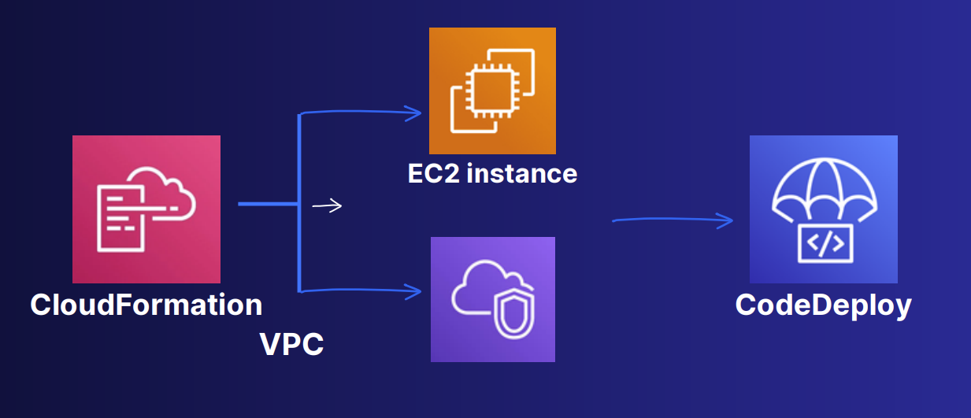

**How I set up CloudFormation**

In the CloudFormation console, I created a stack with new resources (standard), and I uploaded the template file which is **nextworkwebapp.yml.**

Under **Parameters**, I entered my IP address in the **MyIP** field. I found my IP address by visiting <http://checkip.amazonaws.com/> and added /32 to specify that only my specific IP address, meaning only my computer, can access the resources I'm configuring. This helps ensure security.

To finish the setup, I clicked **Create Stack**, and it took a few minutes to complete the stack creation.

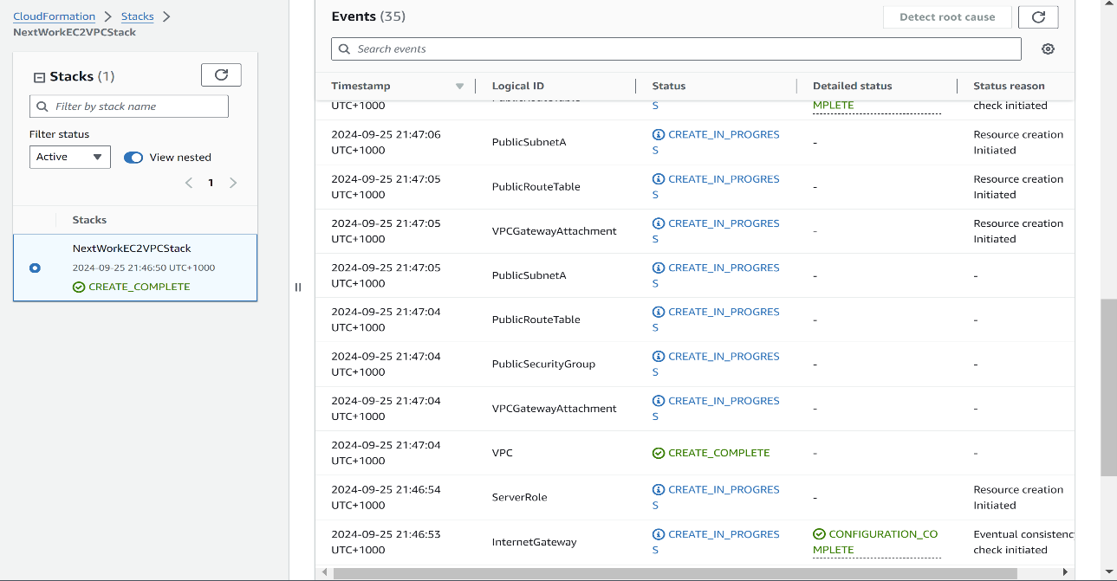

## Create scripts to run the application

Scripts are a set of commands that instruct the terminal to run tasks or automate processes line by line.

In this project, I set up three different scripts in my **nextwork-web-project** folder, and CodeDeploy will execute these scripts to set up and deploy my web application on the target EC2 instance.

The first script I created was **install_dependencies.sh**

**#!/bin/bash**

**sudo yum install tomcat -y**

**sudo yum -y install httpd**

**sudo cat << EOF > /etc/httpd/conf.d/tomcat_manager.conf**

**<VirtualHost *:80>**

**ServerAdmin root@localhost**

**ServerName app.nextwork.com**

**DefaultType text/html**

**ProxyRequests off**

**ProxyPreserveHost On**

**ProxyPass / http://localhost:8080/nextwork-web-project/**

**ProxyPassReverse / http://localhost:8080/nextwork-web-project/**

**</VirtualHost>**

**EOF**

The second script that I used was **start_server.sh**

**#!/bin/bash**

**sudo systemctl start tomcat.service**

**sudo systemctl enable tomcat.service**

**sudo systemctl start httpd.service**

**sudo systemctl enable httpd.service**

The third script that I used was stop_server.sh

#!/bin/bash

isExistApp="$(pgrep httpd)"

if [[ -n $isExistApp ]]; then

sudo systemctl stop httpd.service

fi

isExistApp="$(pgrep tomcat)"

if [[ -n $isExistApp ]]; then

sudo systemctl stop tomcat.service

fi

Next, I created an appspec.yml file to instruct CodeDeploy on the steps and files required for a deployment. It specifies what CodeDeploy should do at various stages of the deployment process, such as which scripts to run and where to place the files.

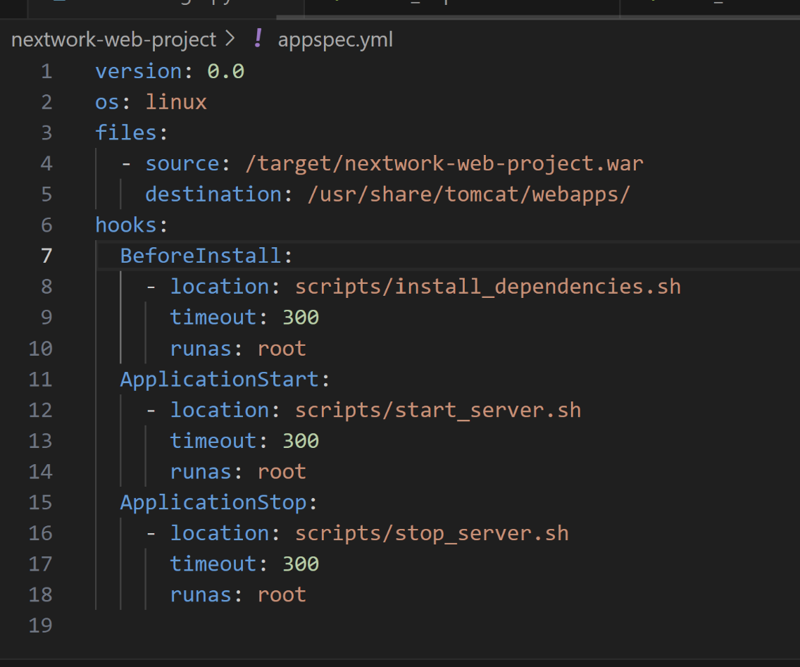

Figure 13: appspec.yml

I added the below lines to my buildspec.yml file to include the newly added scripts folder and appspec.yml file in the WAR file that CodeBuild will create during the build process. By incorporating these new items, it is ensuring that CodeDeploy has all the necessary files to successfully deploy our application.

- appspec.yml

- scripts/**/*

In buildspec.yml script, the above two lines should be inserted at the particular space where it is bolded.

artifacts:

files:

- target/nextwork-web-project.war

- appspec.yml

- scripts/**/*

discard-paths: no

Now I saved all the files and committed all the changes to push in the CodeCommit by running the commands:

cd ~/nextwork-web-project

git add .

git commit -m "Adding CodeDeploy files"

git push -u origin main

**CodeDeployʼs IAM Role**

I created an IAM service role for CodeDeploy because it doesn’t have access to the EC2 instance for deployments. To grant that access, I established the IAM service role for CodeDeploy.

To set up CodeDeploy’s IAM role, I attached an AWS managed policy called AWSCodeDeployRole, which automatically adds the default permissions that CodeDeploy typically needs.

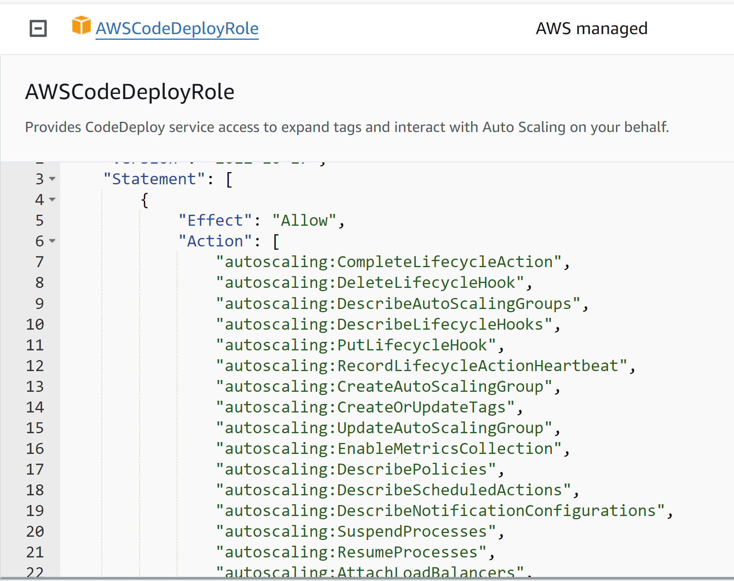

Figure 14: IAM role for CodeDeploy

## CodeDeploy application

A CodeDeploy application refers to a saved configuration/setup template for deploying my web app.

To create a CodeDeploy application, I needed to select a compute platform, which determines the environment where my web application will be hosted. Each compute platform comes with its own set of requirements for deploying a web app.

The compute platform I chose was EC2 because I am using an EC2 instance as my web server. Choosing EC2 gives me the most control of all the three compute platform options, and it’s also beneficial for my learning, as I will be exposed to more configuration options

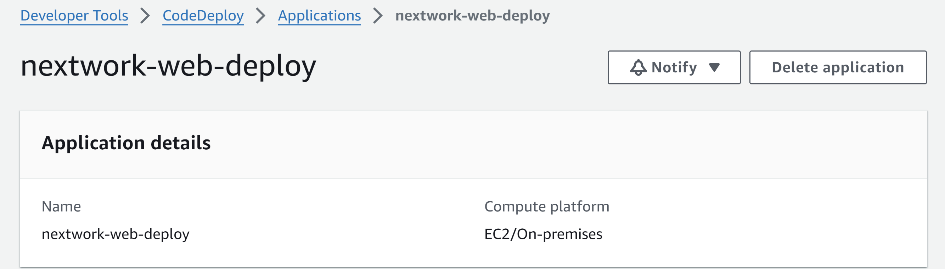

Deployment group

A deployment group means the configurations for a specific deployment scenario.

To create a deployment group, I set up a:

1. A service role: It is an IAM role that I am using for my deployment group to grant CodeDeploy access to my EC2 web server instance.
2. Deployment type: The deployment type is the mode that CodeDeploy will use to carry out your web app's deployment. I chose **In-place**, which means the application will be updated on the existing EC2 instances.

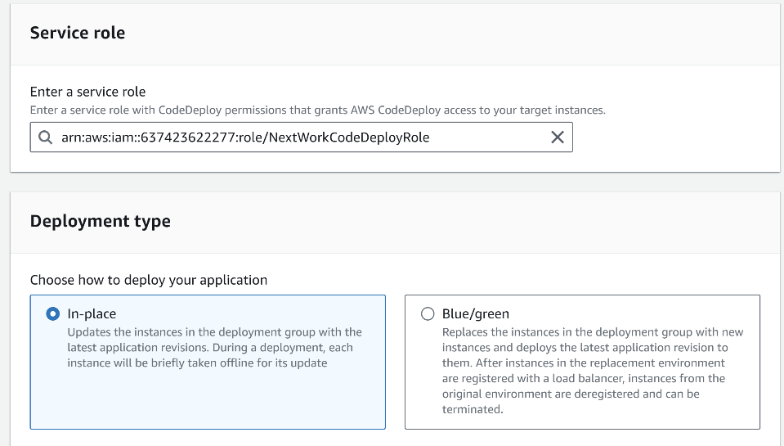

Figure 15: service role and deployment type in settings

1. Environment configuration: It refers to the type of servers that will be used to deploy my web app—in this case, I used Amazon EC2 instances without the need for Auto Scaling groups.
2. The CodeDeploy Agent: It is a CodeDeploy's helper that communicates with my EC2 web server and ensures it follows the deployment instructions.
3. Deployment setting: It is like rules for how the deployment should happen, whether the deployment should occur in different stages or all at once.

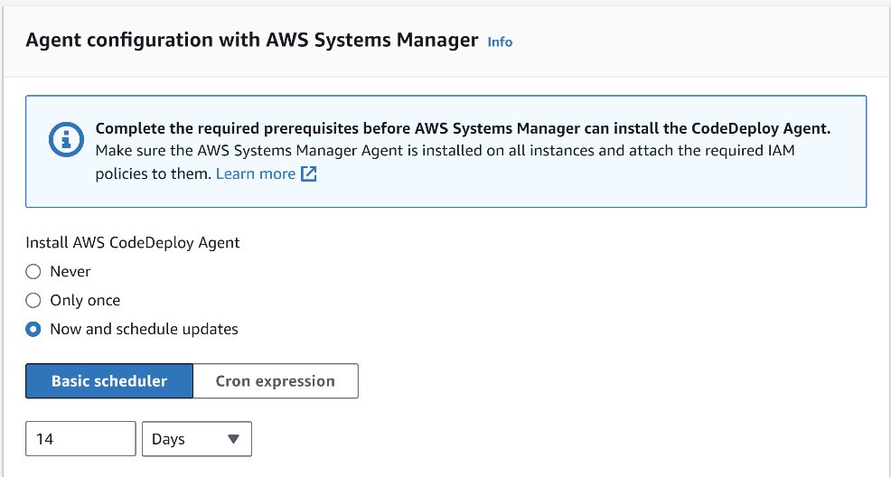

Creating the deployment

## I pasted the S3 URI of the WAR file stored in S3 bucket into the Revision location field in the deployment settings.

## .zip is still selected as the Revision file type.

## Now, I clicked create deployment.

## Next, I went to EC2 instance and opened the Public IPv4 address. It opened with https format which I edited manually as http.

After the webpage was loading sometime, it displayed my web app. The Below diagram shows the display of my web app.

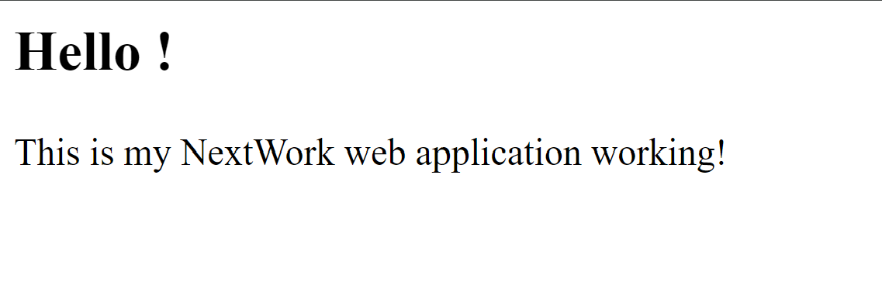

**My CI/CD pipeline so far...**

1. AWS Cloud9 is responsible for debugging, editing and modifying the code and output of my webapp.
2. AWS CodeCommit is responsible for storing my progress and changes I make on my IDE.
3. AWS CodeArtifact is responsible for securing my dependencies needed for developments.
4. AWS CodeBuild is responsible for compiling my source codes, run tests and produce packages which will be used for deployments.
5. AWS CodeDeploy is responsible for making my web application live to the public users.

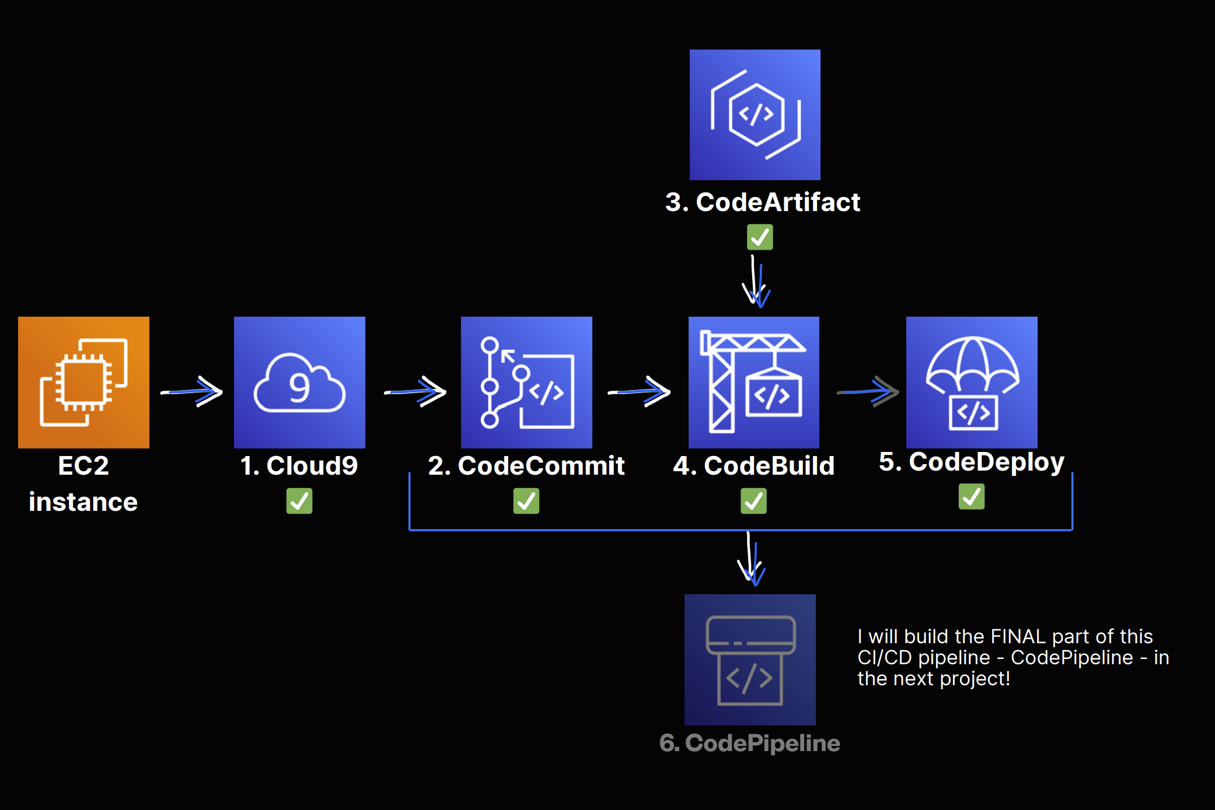

**Key learnings from this project:**

1. **Understanding Deployment Pipelines**: I gained valuable insights into setting up and managing deployment pipelines using AWS CodeDeploy, which enhanced my understanding of automating application deployments and ensuring consistent updates across environments.
2. **Configuration Management**: The project deepened my knowledge of configuration management tools and best practices, allowing me to effectively handle complex configurations and streamline the deployment process.
3. **Collaboration and Version Control**: I learned the importance of collaboration in a team setting and how using version control systems like AWS CodeCommit facilitates smooth workflows, enabling efficient tracking of changes and improving team productivity.

[NextWork.org](https://community.nextwork.org/c/i-have-a-question?automatic_login=true)

# Everyone should be in a job they love.

Check out [nextwork.org](https://community.nextwork.org/c/i-have-a-question?automatic_login=true) for more projects

